# PART A)

50x50 Direct Row major

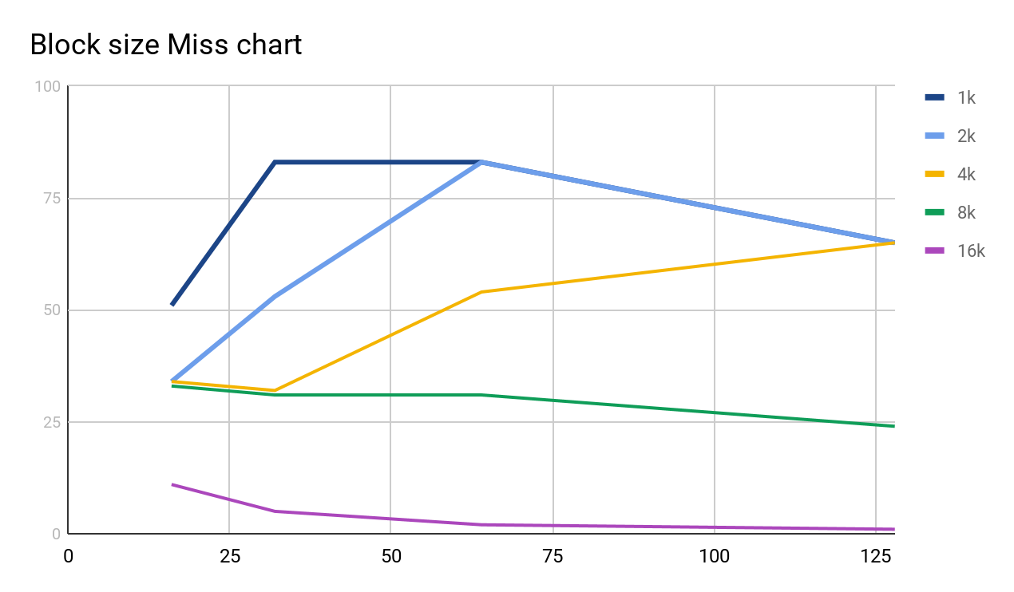

50x50 Direct column major



200x200 Direct row Major

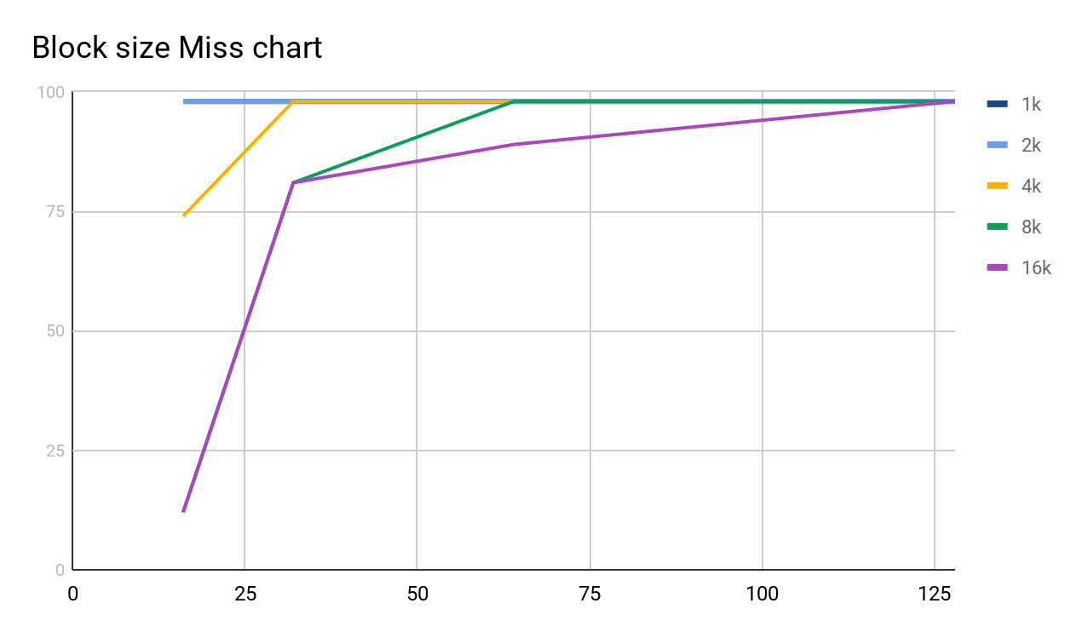

200x 200 Direct Column major



# PART B)

Best, Med, Worst LRU policy Fully Associative

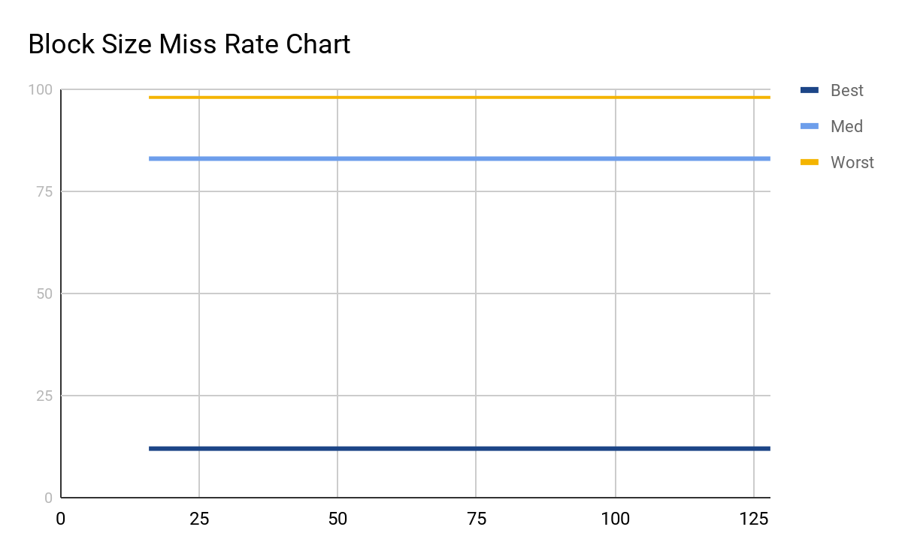

Best, Med, Worst Random Policy Fully Associative

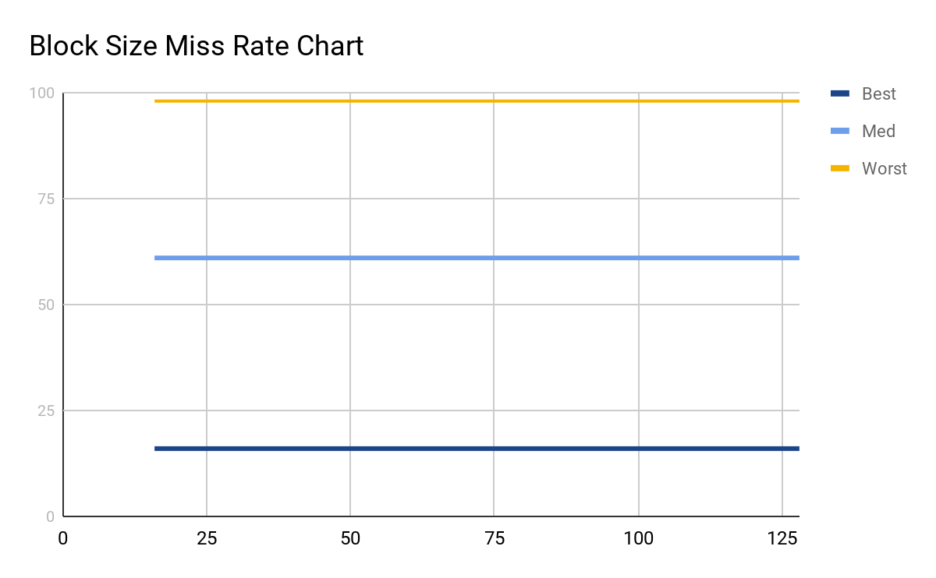

# PART C)

Best, med, worst and 2,4,8,16 set sizes

